Social Media Package
Front Line Defenders
Sex Worker Rights Defenders At Risk

Captions | Images
Don't miss @FrontLineHRD's latest report "Sex Worker Rights Defenders At Risk" launching August 12.  The 4 year investigation is the first to document attacks on sex worker activists that are perpetrated in retaliation for their human rights work.  Info: https://frontlinedefenders.org/swrd | 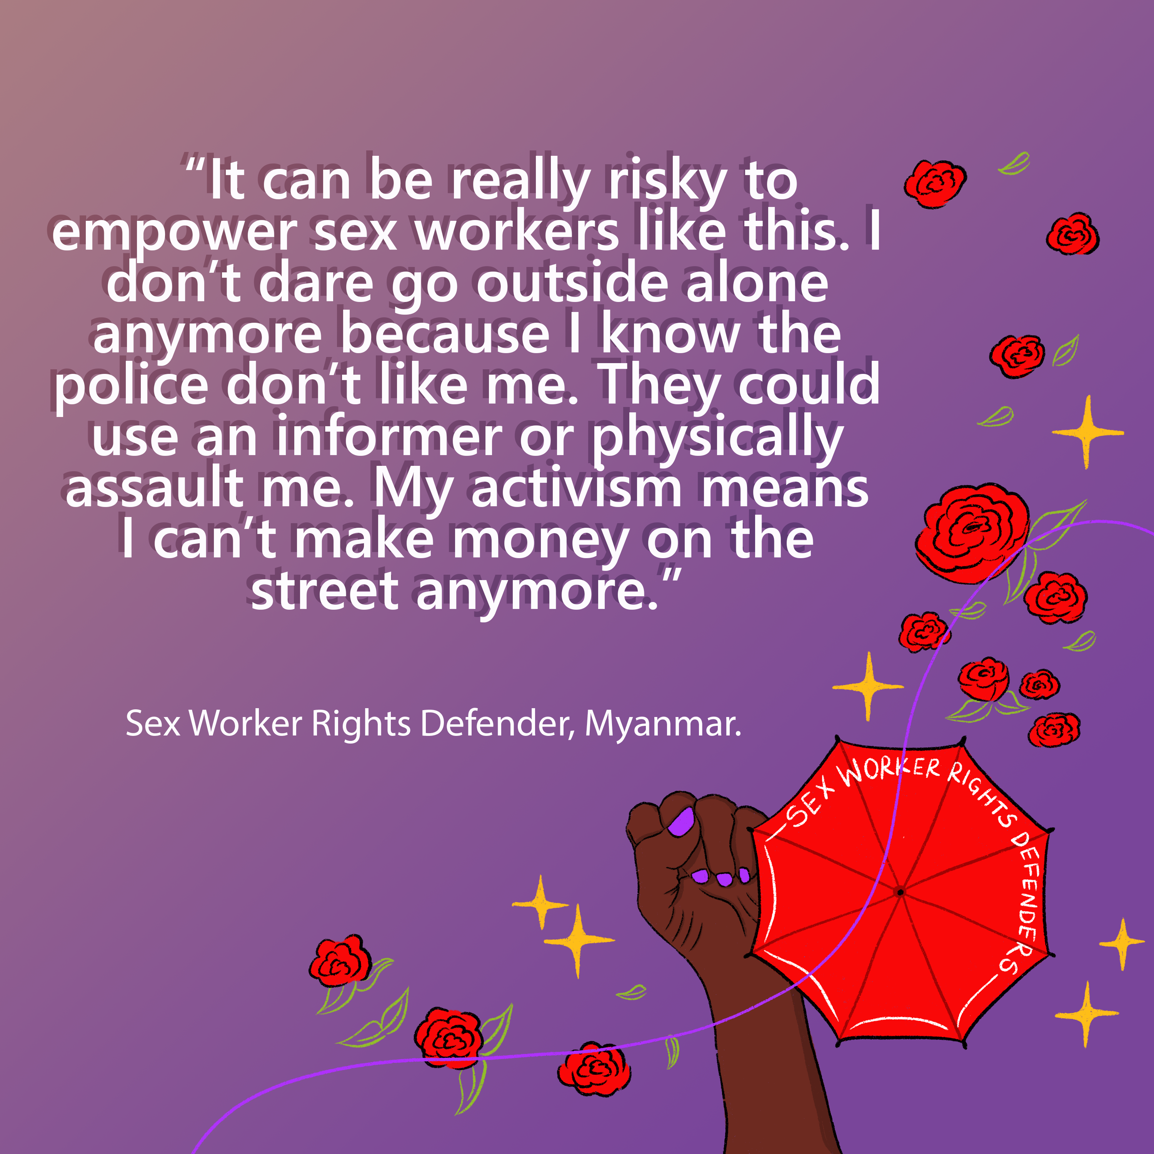  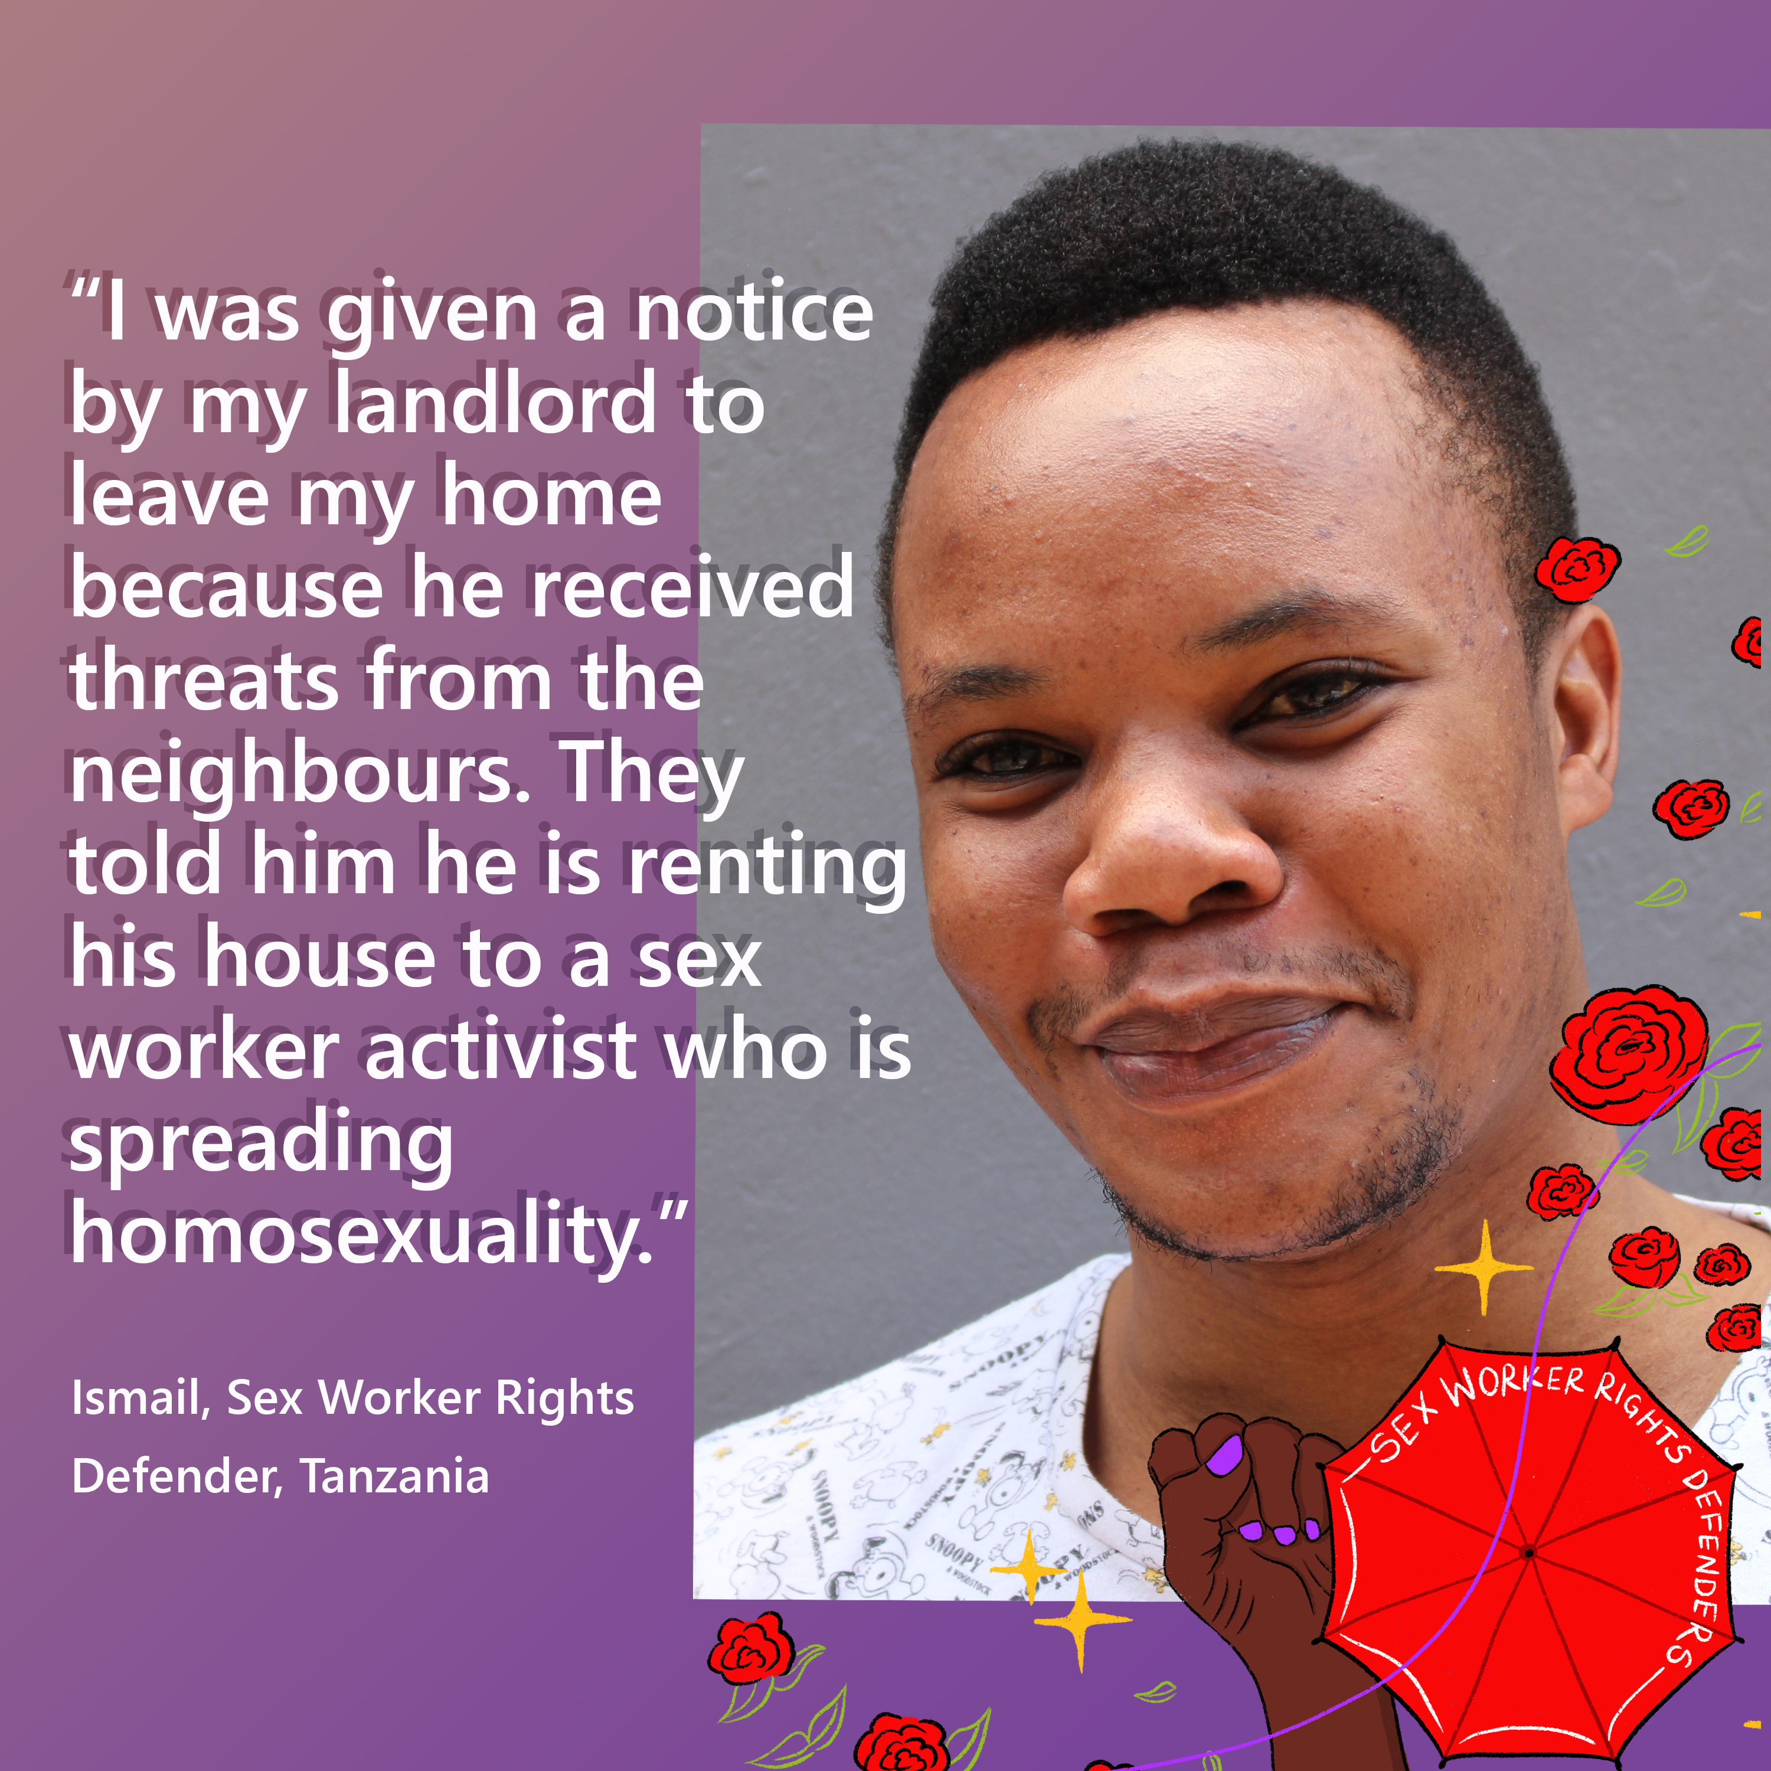
Sex worker rights defenders are experts in accessing dangerous, closed spaces (including parlous & brothels) to do human rights work that no one else can do. Hear their strategies in @FrontLineHRD upcoming report, launching 12 August.  Join the event: https://frontlinedefenders.org/swrd | 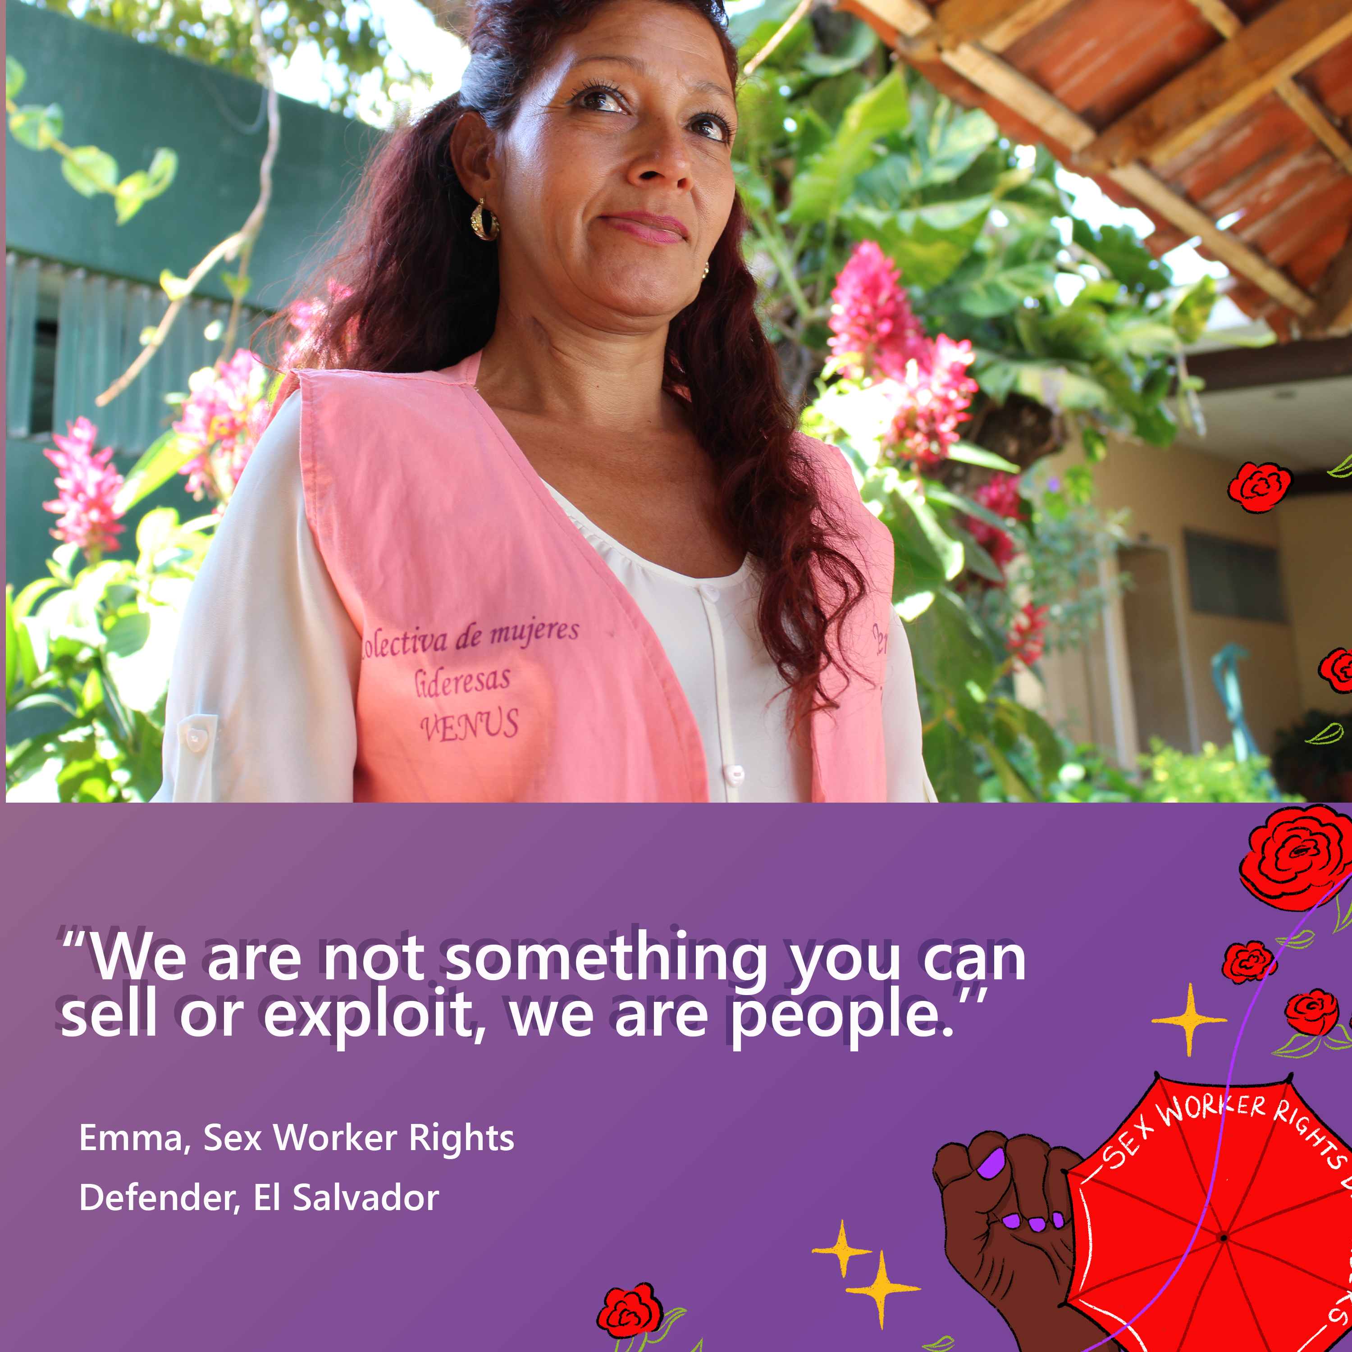  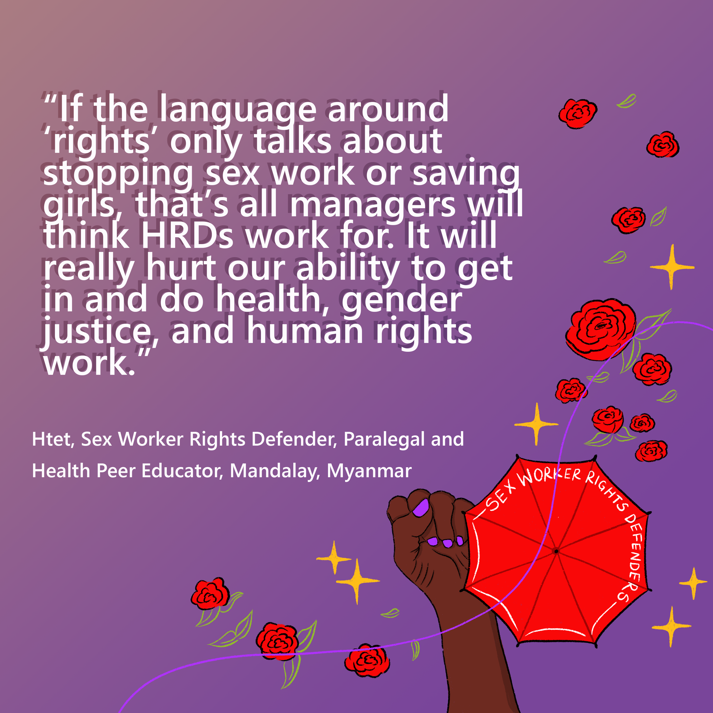
The 4-year @FrontLineHRD investigation into attacks on Sex Worker Rights Defenders launches 12 Aug  Join comedian @margaretcho, UN SR @drtlaleng, author @melissagira, lead researcher @neo_chlo, FLD's @ettrick49 and activists from @GlitsInc & @apnsw  https://www.frontlinedefenders.org/SWRD | 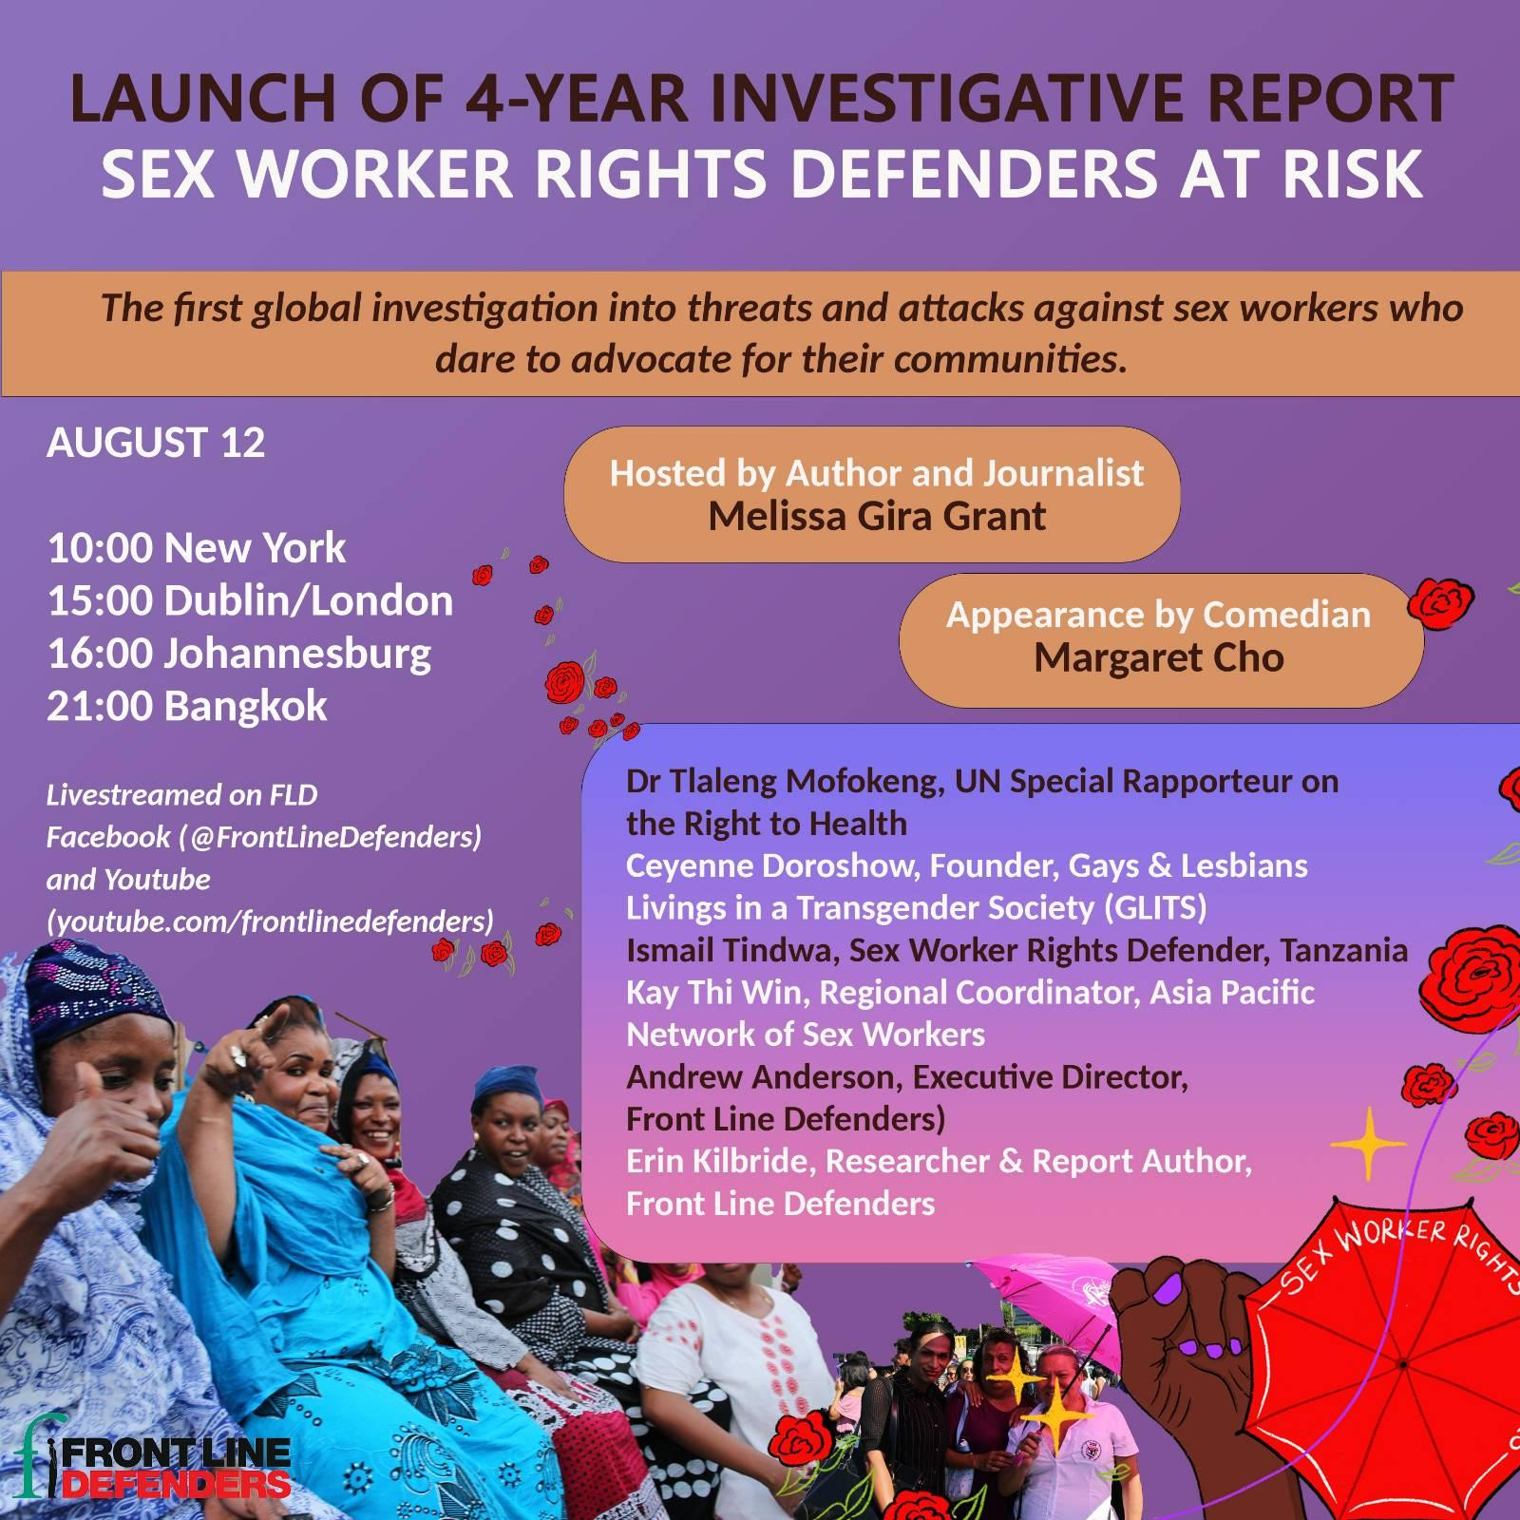
Human rights defenders such as Hosna are discriminated against because of their identities as sex workers. In it's latest investigation, @FrontLineHRD documents the unique threats facing sex workers who dare to advocate for their communities.  https://frontlinedefenders.org/swrd | 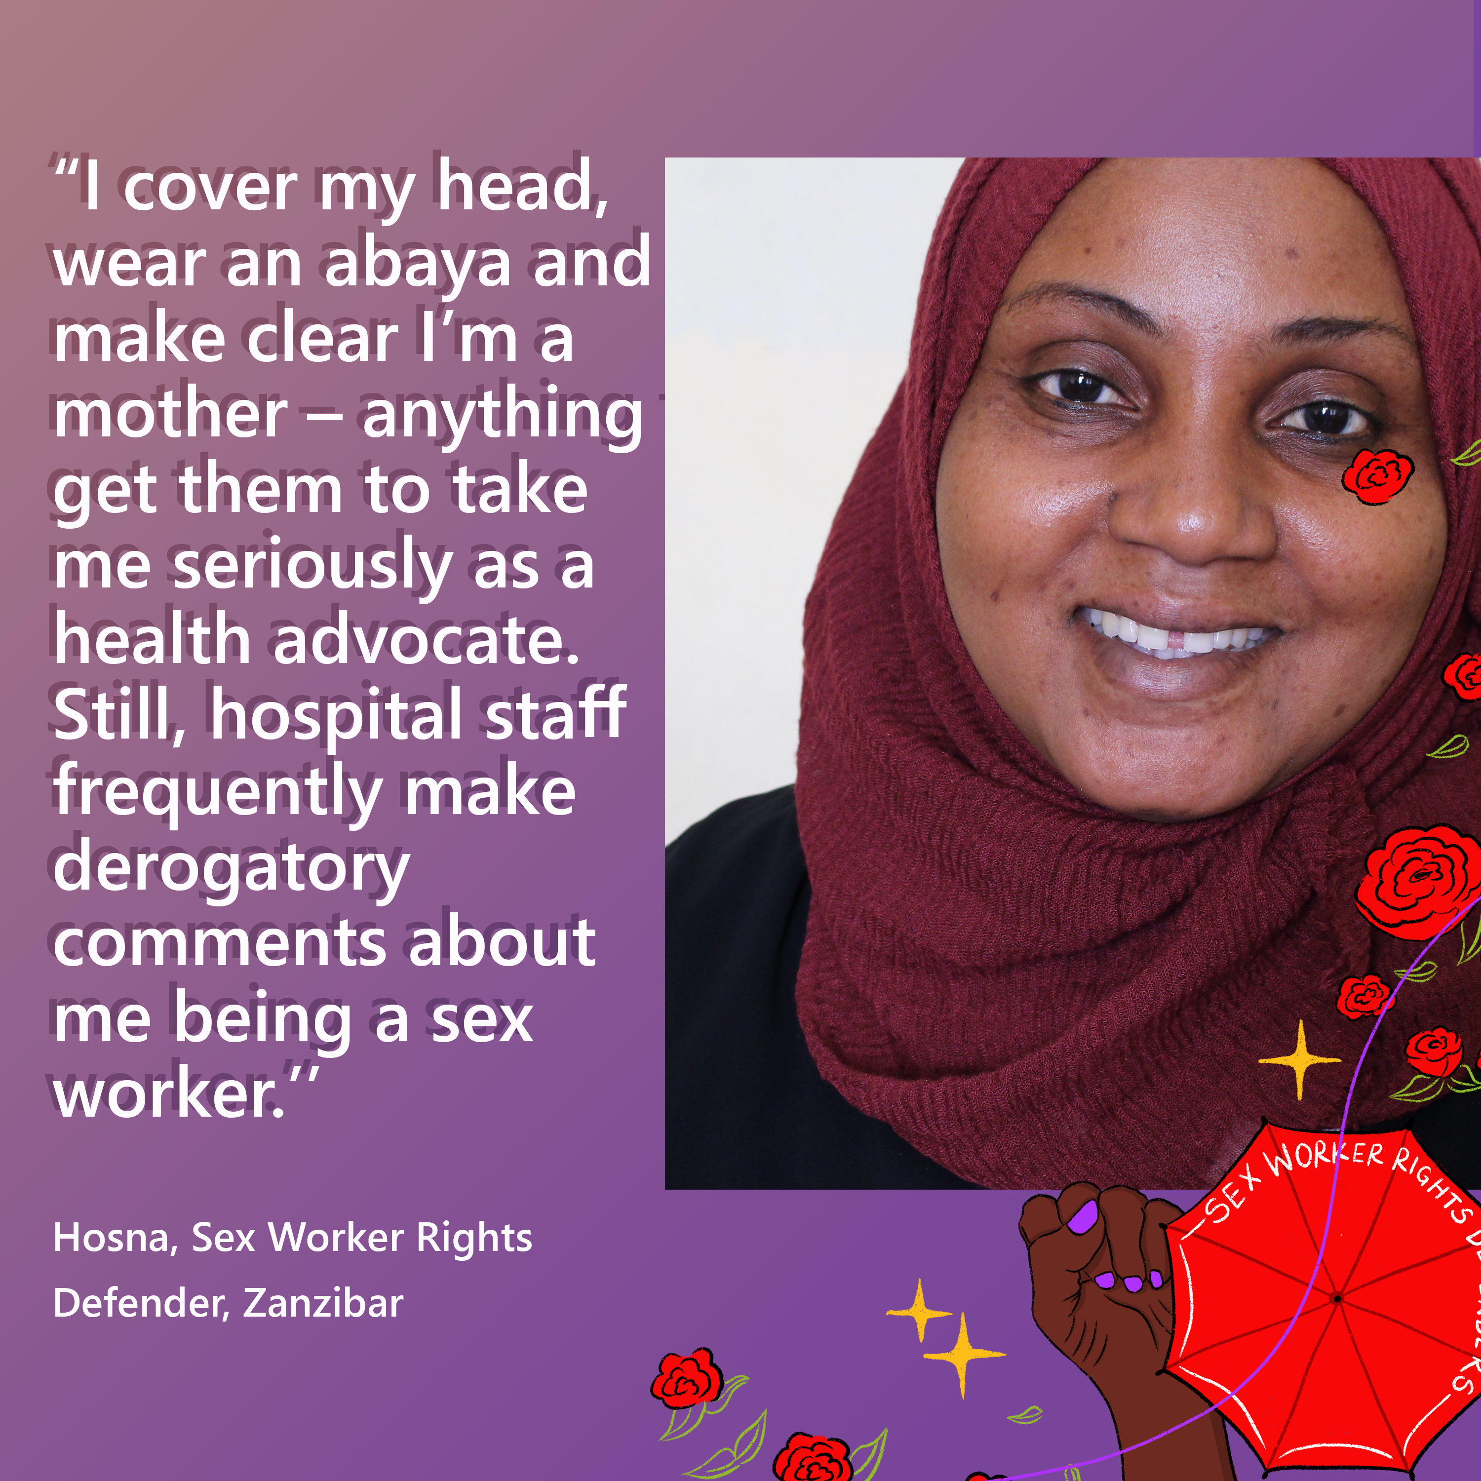  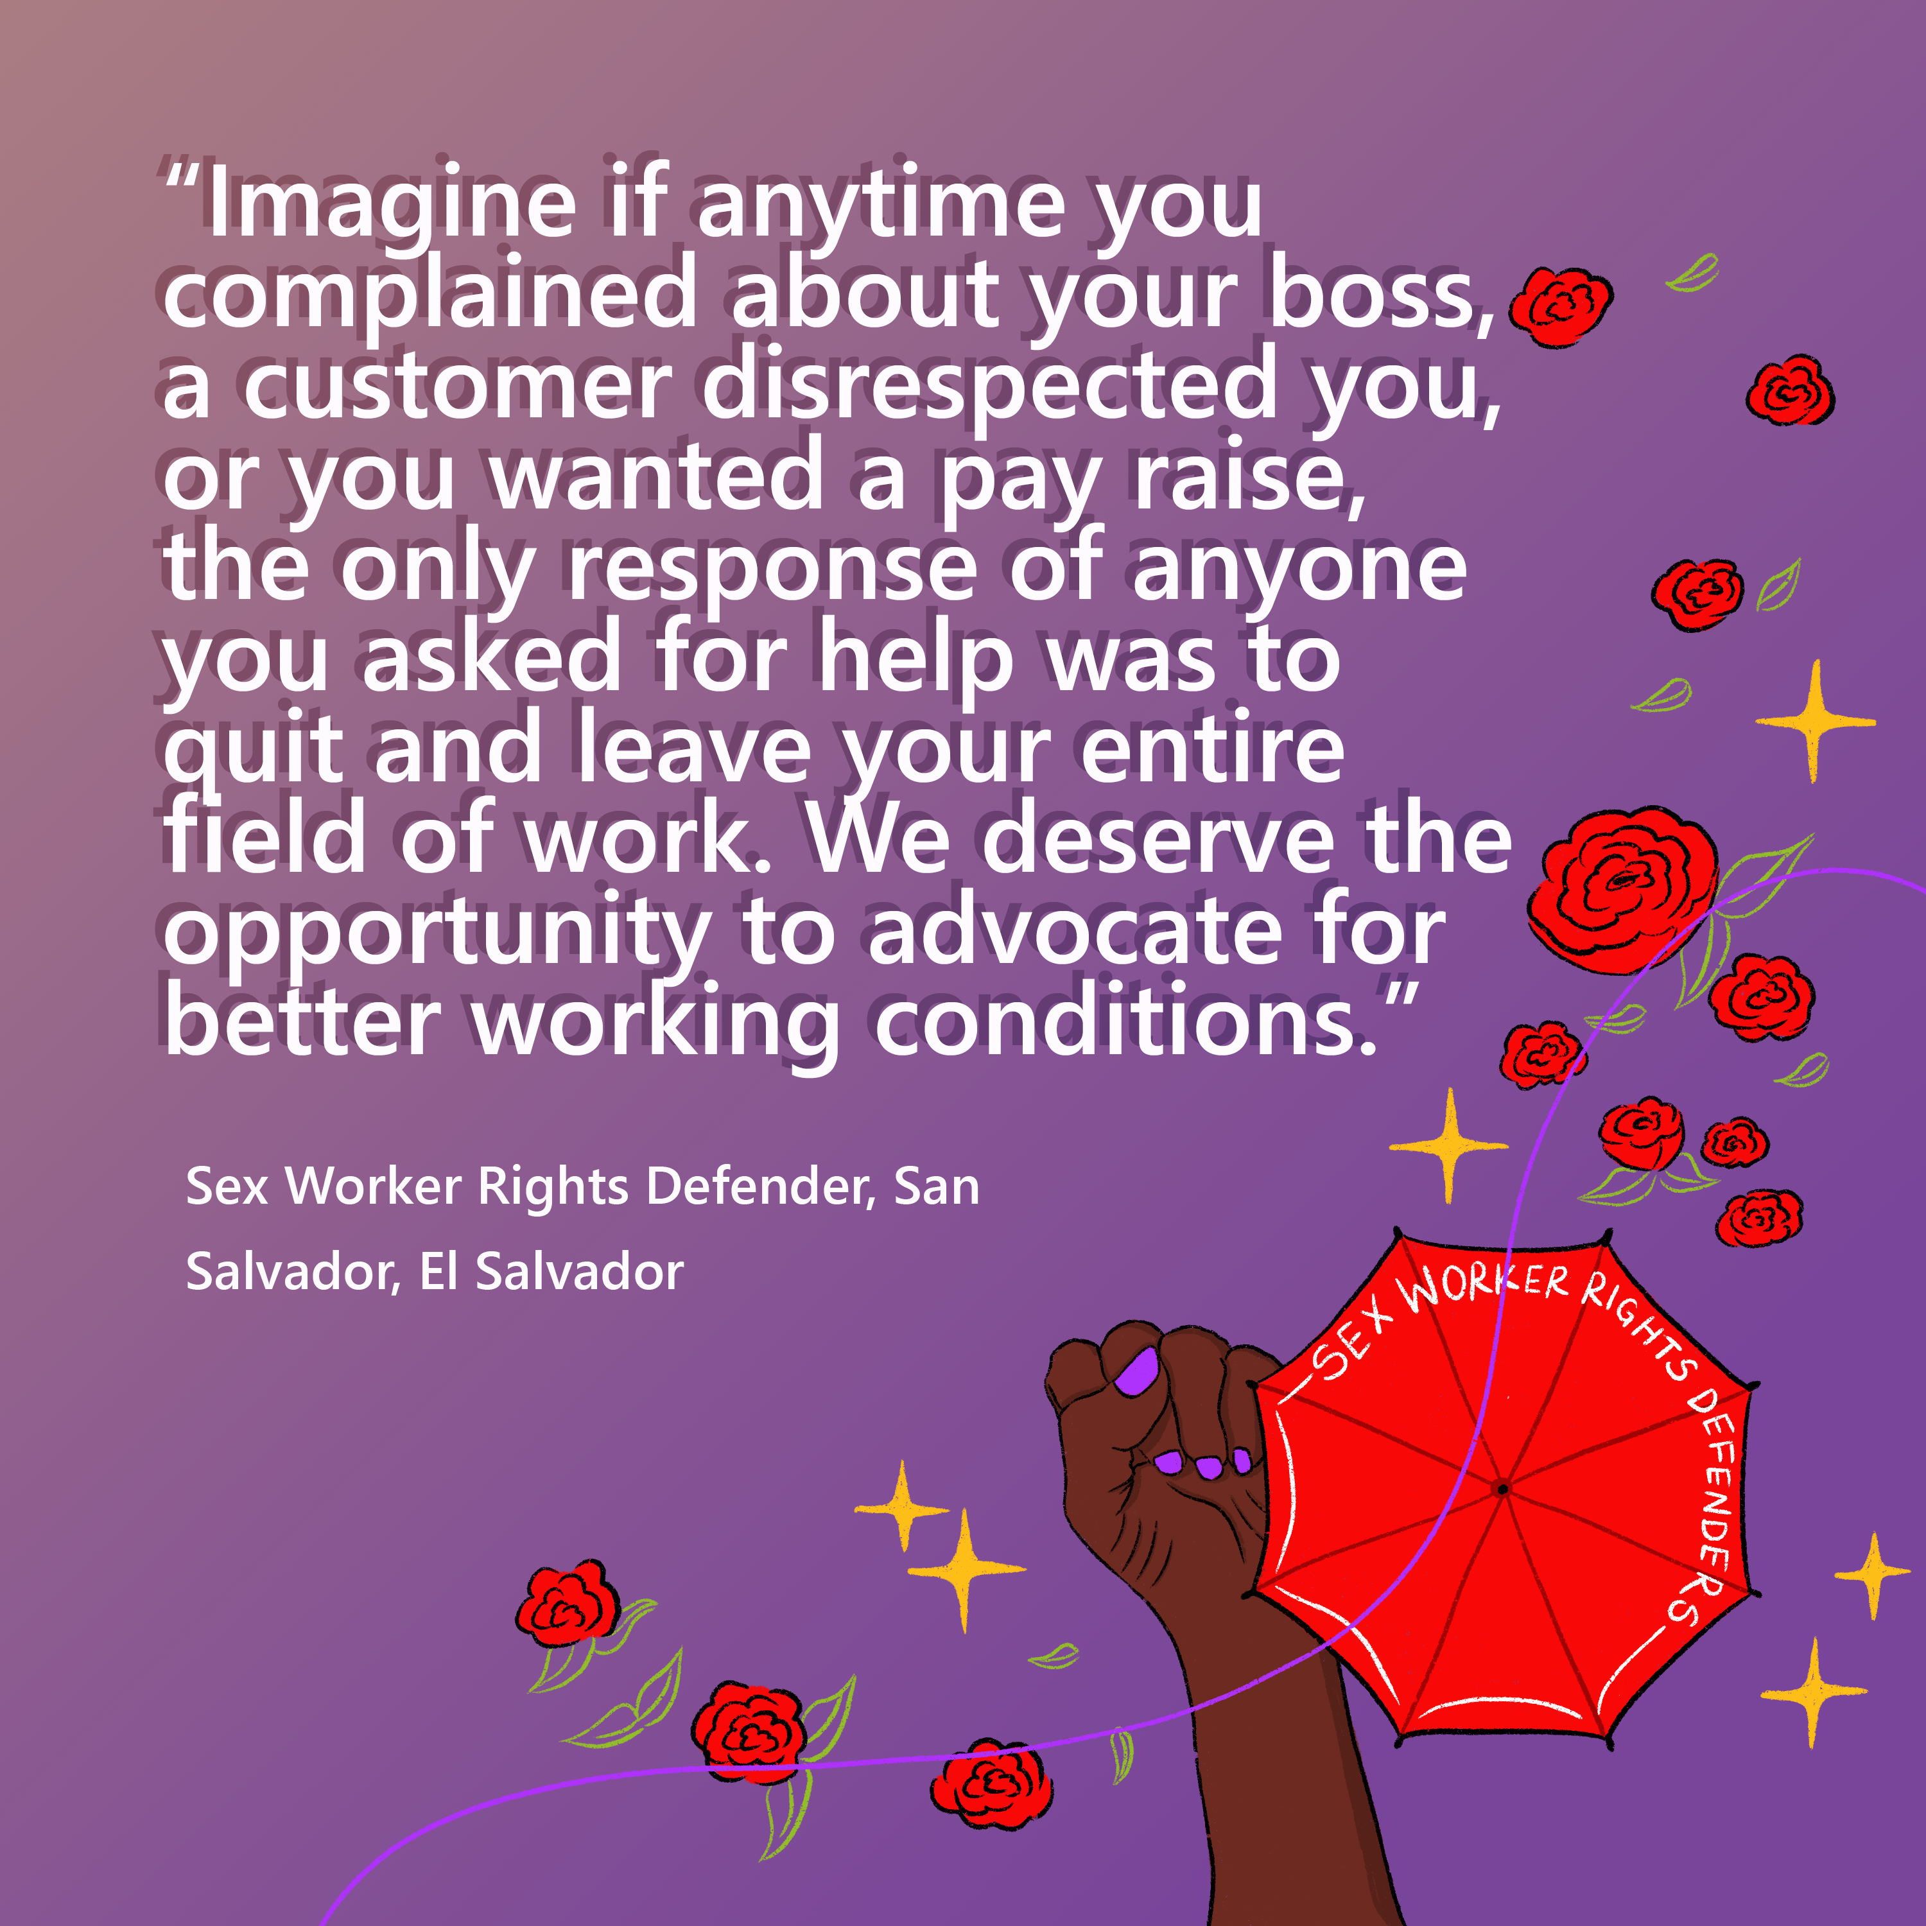
Sex workers around the world face rampant physical, emotional and sexual violence from police. @FrontlineHRD spent 4 years investigating attacks on the brave sex worker activists who defend others in their communities.  Join the launch on 12 August: https://frontlinedefenders.org/swrd | 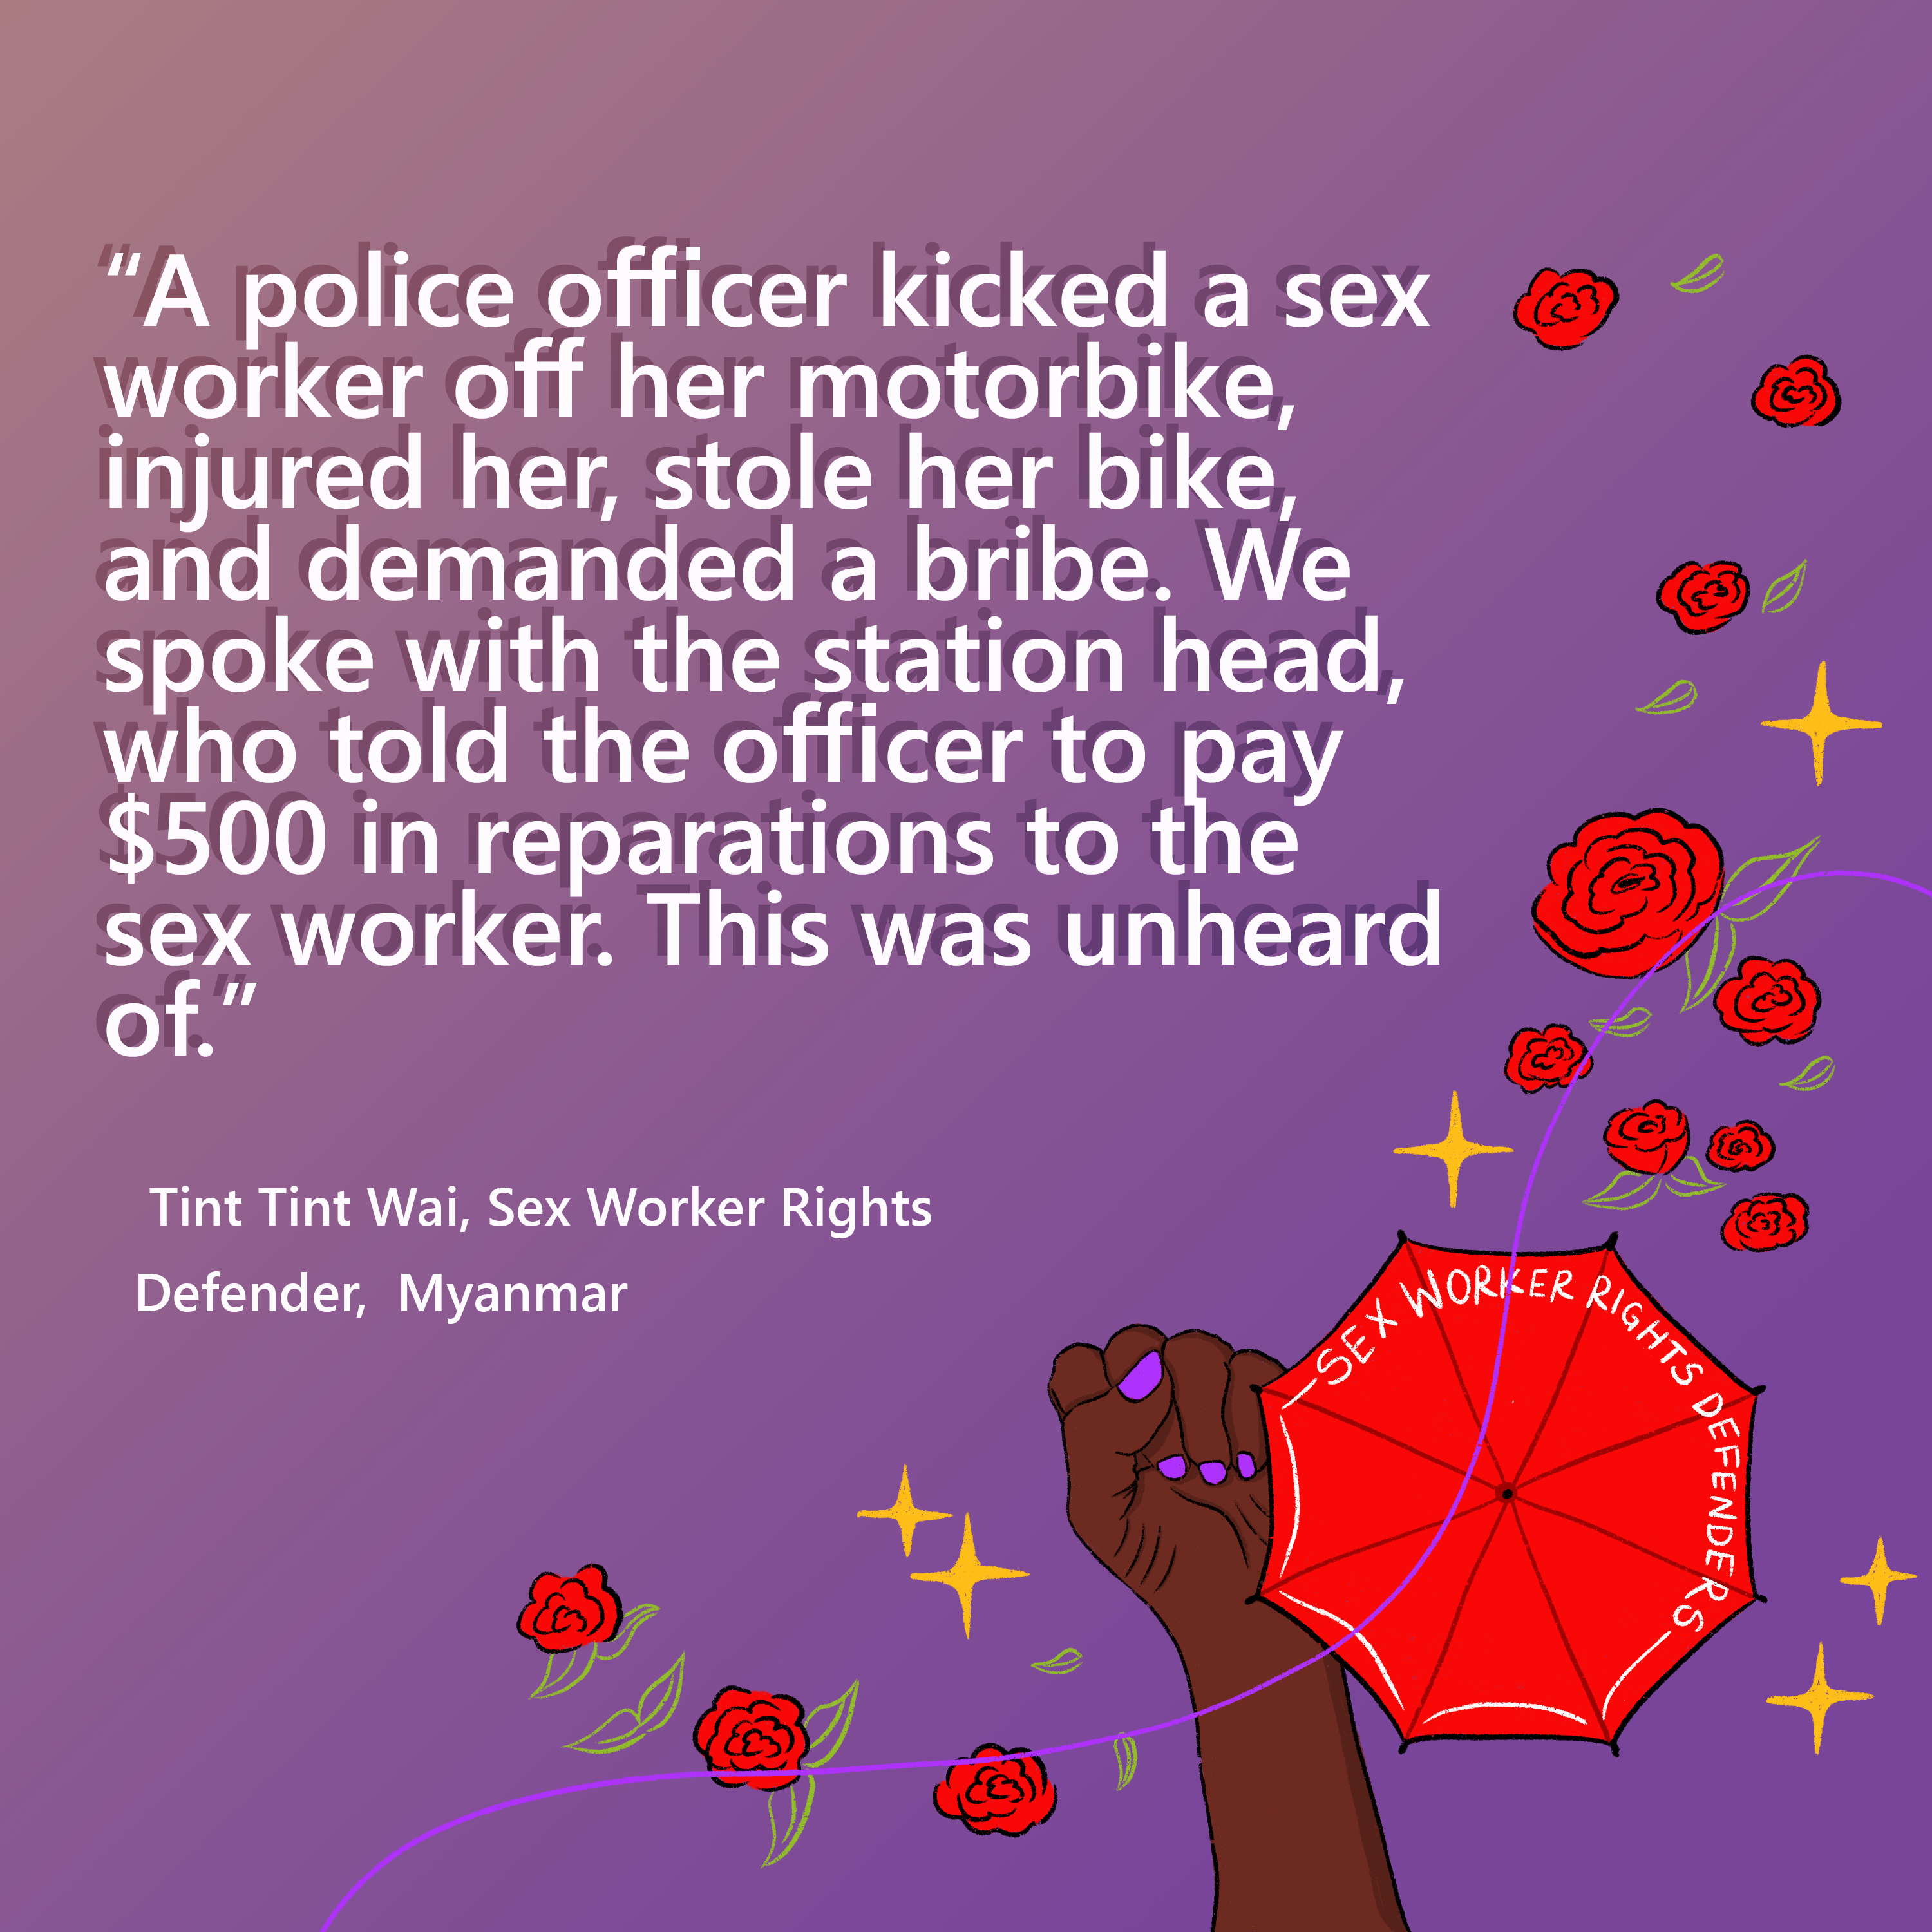
 | 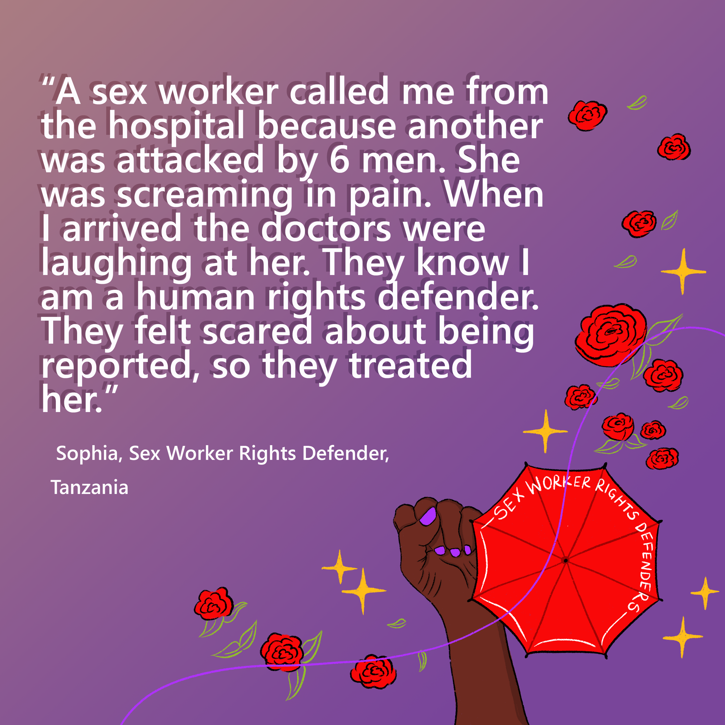
We stand with @FrontLineHRD to affirm that sex worker rights defenders are human rights defenders.  They face targeted attacks directly tied to their HRD work, and deserve HRD protection support.  As a human rights community, we need to end the stigma. https://frontlinedefenders.org/SWRD | 