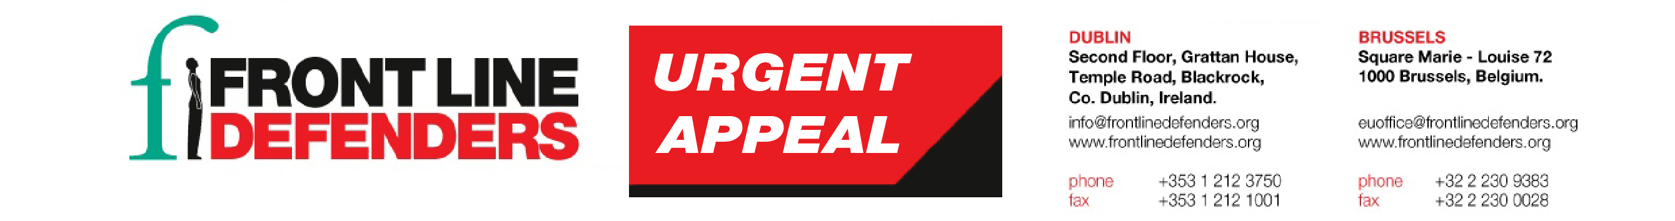
12 January 2017
Colombia: Assassination of land rights defender Aldemar Parra García
On 7 January 2017, land rights defender, Mr Aldemar Parra García, was shot by unknown men riding a motorcycle in El Hatillo, Cesar.
Aldemar Parra García was a community leader and a land rights defender in El Hatillo, where he advocated against the forced displacement of his community as a result of environmental destruction and pollution caused by coal mining companies.
On 7 January 2017, two unknown men riding a red motorcycle shot Aldemar Parra García in the back three times, killing him. Aldemar Parra García was the nephew of community leaders Alfonso Martínez, Yolima Parra and Diana Fonseca, all of whom have been constantly threatened and harassed as a result of their human rights work. Community leaders in El Hatillo advocate for better living conditions even as they are forcibly displaced due to environmental destruction caused by coal mining. El Hatillo residents have also seen agriculture and fishing compromised as a result of the operations of five mines that surround the community: Calenturitas, owned by Grupo Prodeco; Descanso Norte and Pribbenow, owned by Drummond; and El Hatillo and La Francia, owned by the Murray Energy Corporation.

Front Line Defenders is extremely concerned over the high number of killings of human rights defenders in Colombia, despite the developments of the peace process. As Front Line Defenders reported, at least 85 human rights defenders were killed in Colombia in 2016 as a result of their human rights work. More human rights defenders have been killed in Colombia in 2016 than in any other country. On the same week of the killing of Aldemar Parra García, the Inter-American Court on Human Rights found the State of Colombia responsible for not preventing the murder of human rights defender Ana Teresa Yarce in 2004. On its ruling of 10 January 2017, the Court found that the State failed to provide the necessary protective measures to safeguard the life of Ms Yarce. The Court reiterated that States must adopt protection measures for human rights defenders that are appropriate to their human rights work and that can be modified in accordance to the level of risk they face, which should be determined by risk assessments.
Front Line Defenders strongly condemns the killing of human rights defender Aldemar Parra García and urges the Colombian authorities to provide adequate protection to all human rights defenders in the country.
Front Line Defenders urges the authorities in Colombia to:

- Carry out an immediate, thorough and impartial investigation into the killing of Aldemar Parra García, with a view to publishing the results and bringing those responsible to justice in accordance with international standards;

- Strongly condemn the killing of Aldemar Parra García and publicly state the unacceptability of attacks against human rights defenders;

- Investigate reports of death threats and other forms of intimidation against human rights defenders in Colombia, and adopt immediate measures to ensure their protection;

- Guarantee in all circumstances that all human rights defenders in Colombia are able to carry out their legitimate human rights activities without fear of reprisals and free of all restrictions, including judicial harassment.

